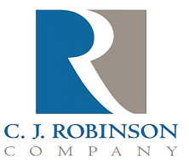
PO Box 217
East Greenville, PA 18041

Phone: (215) 679-3970
Fax: (215) 679-3761
Website: http://www.cjrobinson.com

EHA Statement

To Whom It May Concern,

C.J. Robinson Co., Inc. certifies that none of its paraffin wax, oil or petrolatum products contain nor comes into contact with 2-ethylhexyl-4-dimenthylaminobenzoate, known by its acronym EHA.

Gary Barnes
C.J. Robinson Regulatory Issues

